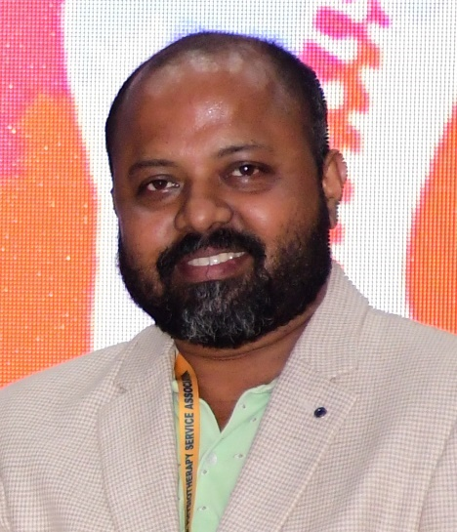

**DR SIDHARTH SEKHAR PATRA (PT)**

BPT, MPT (Neurology)

Senior Physiotherapist

He completed his Bachelor in Physiotherapy (**BPT**) from Rajiv Gandhi University Of Health Sciences (RGUHS), Karnataka in 2007 and continued his Master In Physiotherapy (**MPT**) in Neurology and Psycho-Somatic Disorders from the same institute and passed with distinction in 2010. After completion of his study from Bangalore he returned to odisha and started working as Assistant Prof in Hitech College of Physiotherapy, Bhubaneswar. Once in a visit to a patient at Puri on request of his student he felt to start his career as Clinical Physiotherapist in Puri. He started his own physiotherapy clinic at Puri in 2012. He is expert in manual therapy and spinal manipulation. He is working as In-charge Physiotherapist at District Headquarter Hospital (DHH), Puri since 2015. He was deputed as Physiotherapist in the **Banajaga Yatra in Nabakelebara 2015** for the servitors of **Lord Jagannath**. He has donated blood voluntarily more than **56times since 2003**.

As a senior physiotherapist he has experience in the following domain:

* Management of all kinds of patients for physiotherapy in OPD, IPD and ICU of DHH, Puri.
* Resource person in the awareness programs about the physiotherapy services available at government hospitals at different level among the health workers and ASHAs.
* Resource person in the workshop for on **Workplace Stress Management** for working persons of different sectors.
* Expert in pain management by spinal manipulation.
* Conducted many free health camps at different rural areas of puri district.

He has dedicated his time for the rehabilitation and pain management at **Saishree Rehabilitation Unit (a unit of 7SVF)** to serve the people promoting physiotherapy. He is very compassionate n has involved himself in many social activities as a volunteer.

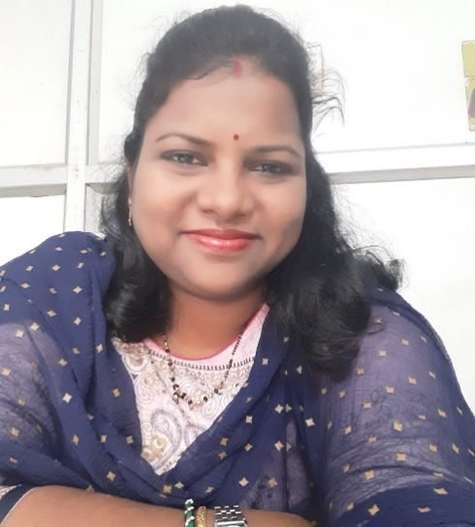

**MRS APARNA MOHANTY**

MA in Psychology, PGDMH (IGNOU)

Clinical psychologist

She completed her graduation (BA) from Samanta Chandra Sekhar College, Puri under **Utkal University** in **2001** and **MA** in Psychology from Utkal University, Bhubaneswar with **Gold Medal**. She started her career as an Assistant HR trainer at Manav Adhayan Kendra, BBSR from 2003 to 2005. Then she joined as Superintendent-Cum-Program Co-Ordinator at Gandhi Institute Of Technical Advancement, Kendrapada from 2005 to 2006. She is working as **Clinical Psychologist** at **District Headquarter Hospital**, Puri since **2006**. As a **Clinical Psychologist** she has gathered experience in the following domain:

* Provide psychotherapy and counselling to individual, couple and parents.
* Implementation of rehabilitation plans/programs for mentally challenged and mentally ill persons.
* Work for orphan children as a member of district child protection unit.
* Work as a conciliator at district legal services authority at session court, puri.
* Guest psychologist at family court, puri and district juvenile justice board, Puri
* Trainer for school teachers, health workers, nurses, community health officers, Ayush doctors, pharmacist an ASHAS on mental health issue every calendar year.
* Resource person in the work shop on **workplace stress management** for working persons of different sectors.

She is working selflessly in the paediatric section of **Saishree Rehabilitation Unit** (a unit of 7SVF) for the cp child, developmental delay, sensory processing disorder and children with autism. She always boosts parents how to take proper care of these special children.

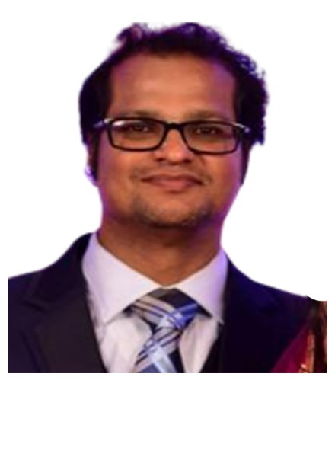

**DR SUBHAJIT BEHERA (PT)**

BPT, MPT (Orthopedic)

He completed his Bachelor in Physiotherapy (**BPT**) from Rajiv Gandhi University Of Health Sciences (RGUHS), Karnataka in 2005 and returned to Odisha. He joined IMS & SUM Hospital, BBSR in 2006. He has been working in all the departments of IMS & SUM Hospital for the physiotherapy management. He is expert in physiotherapy management of patients in ICU and IPD. Following his father and mentor late Dr Pitabas Behera he continued several health camps in different areas of his village Chheda, Cuttack.